**JAVA FOUNDATION TRAINING**

**BATCH 8**

**Name:** Rajalakshmi Ganesh             **Case Study:** TicketBookingSystem

**Tasks 2: Select, Where, Between, AND, LIKE**

**1. Write a SQL query to insert at least 10 sample records into each table.**

* **Venue**

🡪 INSERT INTO venue (venue_id, venue_name, address) VALUES

(1, 'Grand Hall', '123 Main St'),

(2, 'Sunset Arena', '456 Sunset Blvd'),

(3, 'City Hall', '789 Downtown Rd'),

(4, 'Skyline Theater', '321 Uptown Ave'),

(5, 'Riverfront Pavilion', '555 River Rd'),

(6, 'Metro Stadium', '101 Metro Dr'),

(7, 'Imax Theatre', '202 Seaside Ln'),

(8, 'Golden Plaza Hall', '303 Golden St'),

(9, 'Infinity Dome', '404 Emerald Dr'),

(10, 'Space Theatre', '505 Space St');

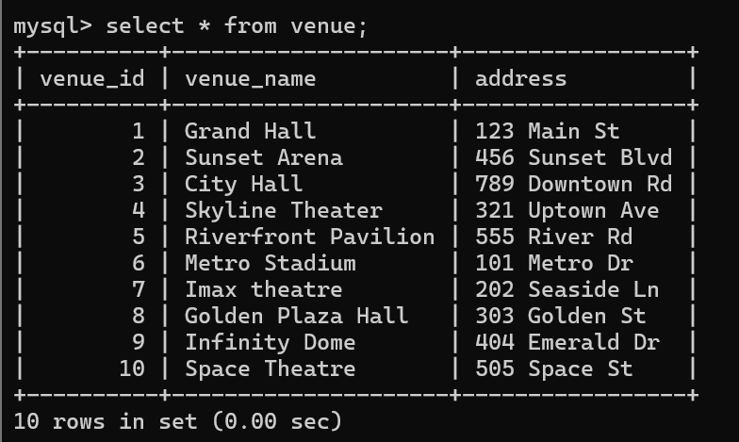

* **Event**

**🡪** INSERT INTO event (event_id, event_name, event_date, event_time, venue_id, total_seats, available_seats, ticket_price, event_type) VALUES

(1, 'Rock Concert', '2025-04-10', '19:00:00', 1, 500, 500, 1200.00, 'Concert'),

(2, 'Football Match', '2025-04-15', '18:30:00', 2, 20000, 20000, 800.00, 'Sports'),

(3, 'K Pop Concert', '2025-04-20', '20:00:00', 3, 30000, 30000, 2500.00, 'Concert'),

(4, 'Movie Premiere', '2025-04-22', '21:00:00', 4, 150, 150, 500.00, 'Movie'),

(5, 'Basketball Game', '2025-04-25', '17:00:00', 5, 15000, 15000, 2000.00, 'Sports'),

(6, 'Orchestra', '2025-04-28', '19:00:00', 6, 400, 400, 1800.00, 'Concert'),

(7, 'Horror Movie', '2025-04-28', '23:00:00', 7, 200, 200, 700.00, 'Movie'),

(8, 'Comedy Show', '2025-05-05', '20:00:00', 8, 600, 600, 600.00, 'Concert'),

(9, 'Badminton Tournament', '2025-05-10', '19:00:00', 9, 5000, 5000, 1200.00, 'Sports'),

(10, 'Sci-Fi Movie', '2025-05-10', '22:00:00', 10, 250, 250, 900.00, 'Movie'),

(11, 'World Cup', '2025-05-27', '19:30:00', 6, 3000, 3000, 1750.00, 'Sports');

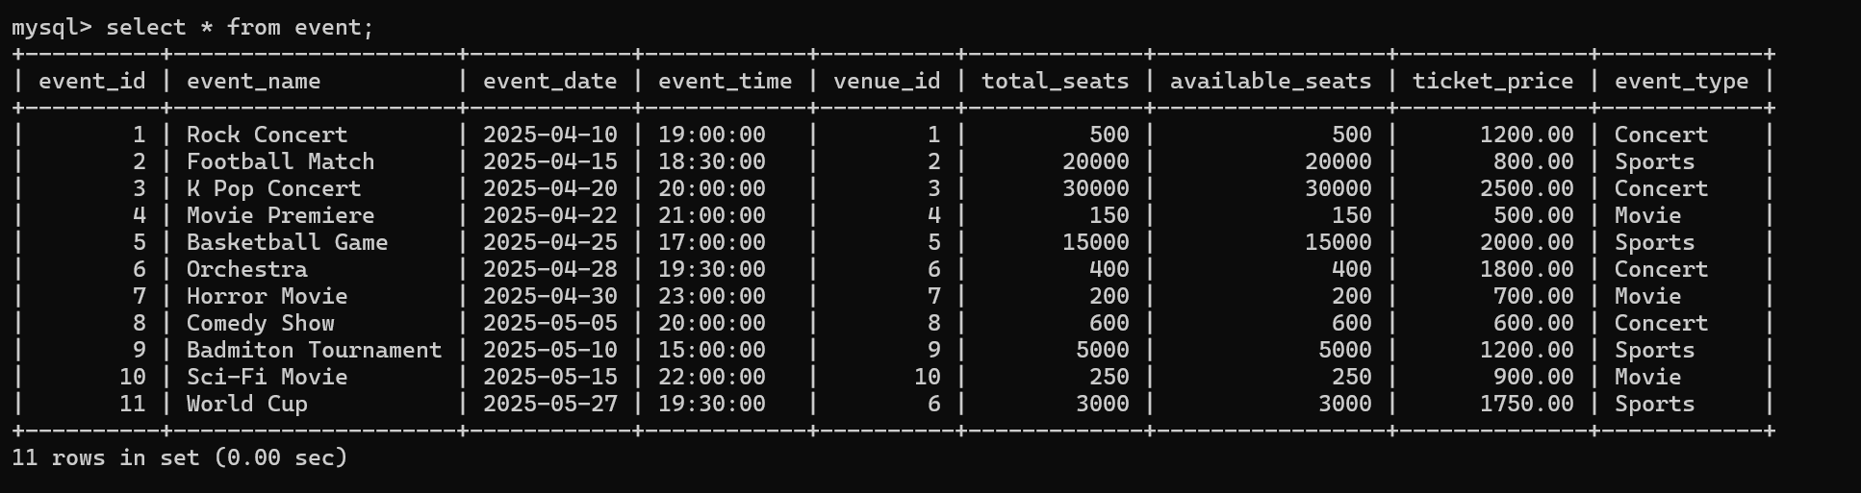

* **Customer**

**🡪** INSERT INTO customer (customer_id, customer_name, email, phone_number) VALUES

(1, 'Alice', 'alice@gmail.com', '9876543210'),

(2, 'Bob', 'bob@gmail.com', '9123456789'),

(3, 'Charlie', 'charlie@gmail.com', '9234567890'),

(4, 'David', 'david@gmail.com', '9345678901'),

(5, 'Emma', 'emma@gmail.com', '9456789012'),

(6, 'John', 'john@gmail.com', '9845372000'),

(7, 'Grace', 'grace@gmail.com', '9678901234'),

(8, 'Adam', 'adam@gmail.com', '9789021345'),

(9, 'Scott', 'scott@gmail.com', '9890123456'),

(10, 'Jack', 'jack@gmail.com', '9901234567');

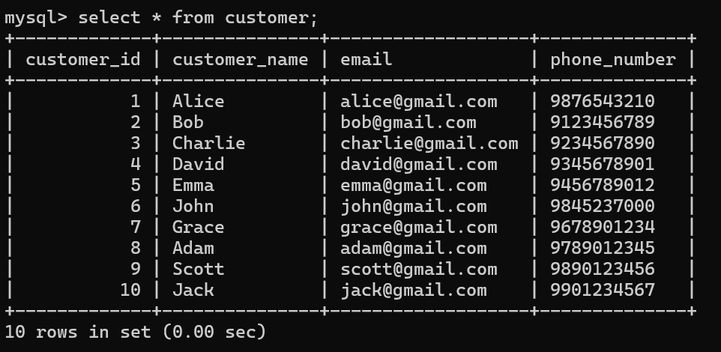

* **Booking**

**🡪** INSERT INTO booking (booking_id, customer_id, event_id, num_tickets, total_cost, booking_date) VALUES

(1, 1, 1, 2, 2400.00, '2025-04-10'),

(2, 2, 3, 3, 7500.00, '2025-04-15'),

(3, 3, 2, 1, 800.00, '2025-04-20'),

(4, 4, 5, 4, 8000.00, '2025-04-22'),

(5, 5, 6, 2, 3600.00, '2025-04-25'),

(6, 6, 4, 1, 500.00, '2025-04-28'),

(7, 7, 7, 5, 3500.00, '2025-04-30'),

(8, 8, 8, 3, 1800.00, '2025-05-05'),

(9, 9, 9, 2, 2400.00, '2025-05-10'),

(10, 10, 10, 4, 3600.00, '2025-05-15');

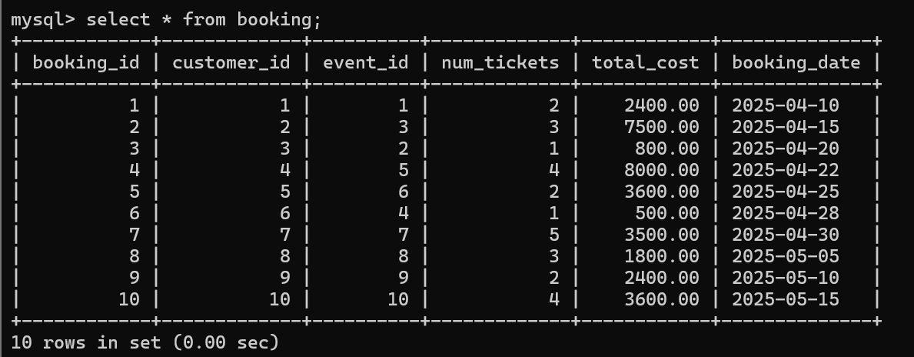

**2. Write a SQL query to list all Events.**

**🡪** SELECT * FROM event;



**3. Write a SQL query to select events with available tickets.**

🡪 SELECT * FROM event

WHERE available_seats > 0;

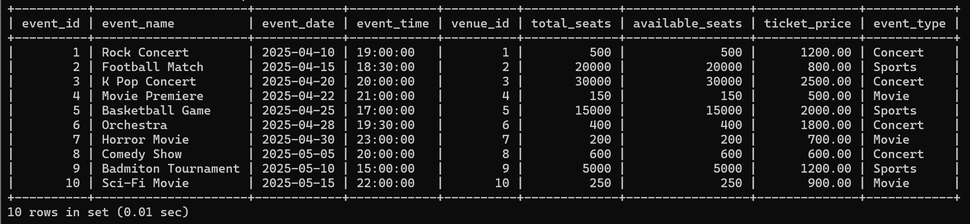

**4. Write a SQL query to select events name partial match with ‘cup’.**

**🡪** SELECT * FROM event

WHERE event_name LIKE ' %cup% ';

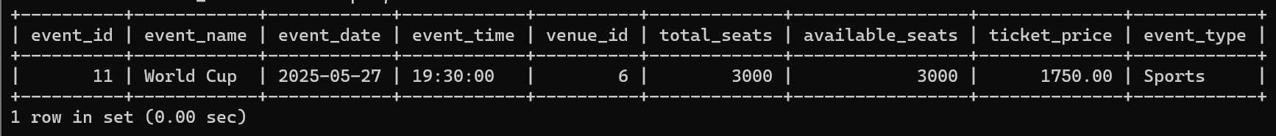

**5. Write a SQL query to select events with ticket price range is between 1000 to 2500.**

**🡪** SELECT * FROM event

WHERE ticket_price BETWEEN 1000 AND 2500;

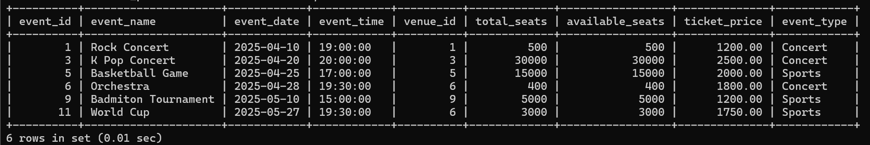

**6. Write a SQL query to retrieve events with dates falling within a specific range.**

**🡪** SELECT * FROM event

WHERE event_date BETWEEN '2025-04-01' AND '2025-05-01';

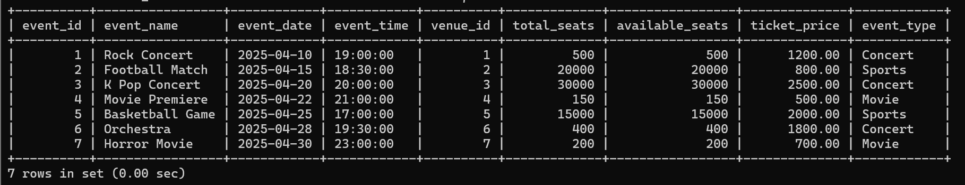

**7. Write a SQL query to retrieve events with available tickets that also have "Concert" in their name.**

**🡪** SELECT * FROM event

WHERE available_seats > 0

AND event_name LIKE ' %Concert% ';

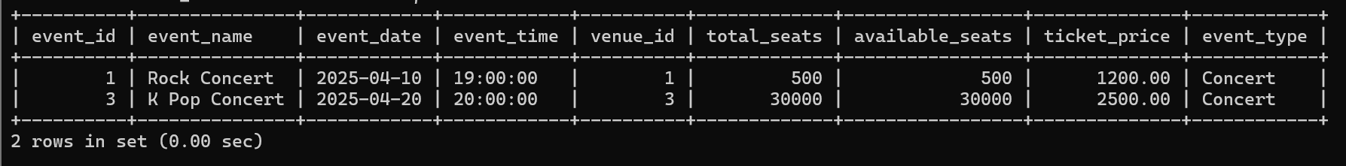

**8. Write a SQL query to retrieve users in batches of 5, starting from the 6th user.**

**🡪** SELECT * FROM customer

WHERE customer_id BETWEEN 6 AND 10;

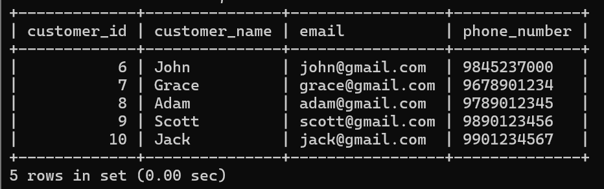

**9. Write a SQL query to retrieve bookings details contains booked no of ticket more than 4.**

**🡪** SELECT * FROM booking

WHERE num_tickets > 4;

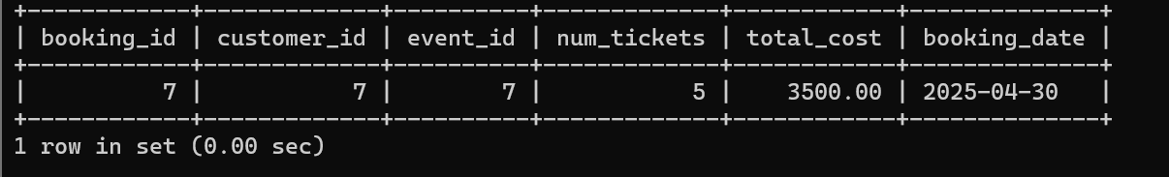

**10. Write a SQL query to retrieve customer information whose phone number end with ‘000’**

**🡪** SELECT * FROM Customer

WHERE phone_number LIKE ' %000 ';

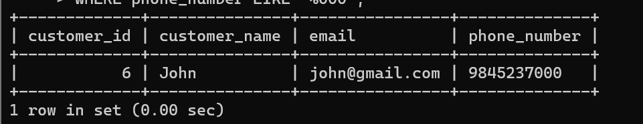

**11. Write a SQL query to retrieve the events in order whose seat capacity more than 15000.**

**🡪** SELECT * FROM Event

WHERE total_seats > 15000

ORDER BY total_seats DESC;

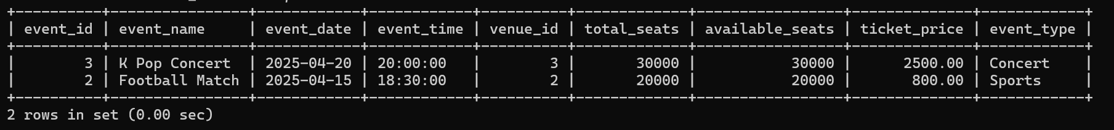

**12. Write a SQL query to select events name not start with ‘x’, ‘y’, ‘z’**

**🡪** SELECT * FROM Event

WHERE event_name NOT LIKE 'x%'

AND event_name NOT LIKE 'y%'

AND event_name NOT LIKE 'z%';

